

Algorytmy optymalizacji

Metoda Davidona-Fletchera-Powella

Stefan Toczek

Jakub Pasula

# Funkcja 1

Wzór: f(x) =

Wynik działania algorytmu:

fmin = 4.306039211198519

xmin = 12.327846144241519

Ilość kroków pętli głównego algorytmu: 1

Ilość kroków złotego podziału: 22

Poszczególne kroki złotego podziału:

|  |  |
| --- | --- |
| X | Y |
| 12.068881230286156 | 4.311247720963294 |
| 13.493387913199754 | 4.419685181055664 |
| 11.188439542637390 | 4.403844153491700 |
| 12.612966784096050 | 4.312471207781958 |
| 11.732566213057355 | 4.333175786038343 |
| 12.276680177976401 | 4.306246933828632 |
| 12.405142425107286 | 4.306503595421678 |
| 12.197322918871983 | 4.307373452054627 |
| 12.325761608310588 | 4.306039697175002 |
| 12.356073700570700 | 4.306099869976863 |
| 12.307006121801747 | 4.306074515184339 |
| 12.337331357508326 | 4.306045664395884 |
| 12.318589452084590 | 4.306046518423121 |
| 12.330172511893622 | 4.306039499492136 |
| 12.332912060407265 | 4.306040910338054 |
| 12.328492866497957 | 4.306039215680796 |
| 12.327446441152199 | 4.306039262170259 |
| 12.329131234652523 | 4.306039271508151 |
| 12.328089981725517 | 4.306039213285652 |
| 12.327846144241519 | 4.306039224179548 |
| 12.328245837997665 | 4.306039211198519 |
| 12.328338976601428 | 4.306039211766550 |

# Funkcja 2

Wzór: f(x) =

Wynik działania algorytmu:

fmin = -1.091234053580764

xmin = [-1.124009445610160, -0.000126938443592]

Ilość kroków głównej pętli algorytmu: 1

Ilość kroków złotego podziału: 21

Poszczególne kroki złotego podziału:

|  |  |  |
| --- | --- | --- |
| X0 | X1 | Y |
| -0.885665563062817 | -0.078453598205620 | -0.861869769122374 |
| -1.271322120733265 | -0.156905364499079 | -1.109503077827378 |
| -1.362362333549873 | -0.175425120891498 | -1.074257204206621 |
| -1.215053098216492 | -0.145458899720385 | -1.114058085557528 |
| -1.180278468126933 | -0.138384908371173 | -1.109815649780068 |
| -1.236546176747224 | -0.149831105871903 | -1.113958609908807 |
| -1.201771044788626 | -0.142757012430527 | -1.113084904560412 |
| -1.223263119592998 | -0.147129014400100 | -1.114263053208762 |
| -1.228336465540841 | -0.148161054288207 | -1.114239229083072 |
| -1.220126946033374 | -0.146491041700656 | -1.114220365394899 |
| -1.225200675374574 | -0.147523159580140 | -1.114267485054173 |
| -1.226398599589143 | -0.147766846012147 | -1.114261856030274 |
| -1.224460778887126 | -0.147372646940954 | -1.114267768164846 |
| -1.224003207774887 | -0.147279566034520 | -1.114266721984902 |
| -1.224743278675521 | -0.147430114153520 | -1.114267948016116 |
| -1.224918057113263 | -0.147465668267350 | -1.114267881172107 |
| -1.224635445451164 | -0.147408178296998 | -1.114267921343610 |
| -1.224810107936691 | -0.147443708823375 | -1.114267938533253 |
| -1.224702161280761 | -0.147421749892158 | -1.114267943959278 |
| -1.224768875552525 | -0.147435321170418 | -1.114267946735985 |
| -1.124009445610160 | -0.000126938443592 | -1.091234053580764 |

Wizualizacja kroków algorytmu:

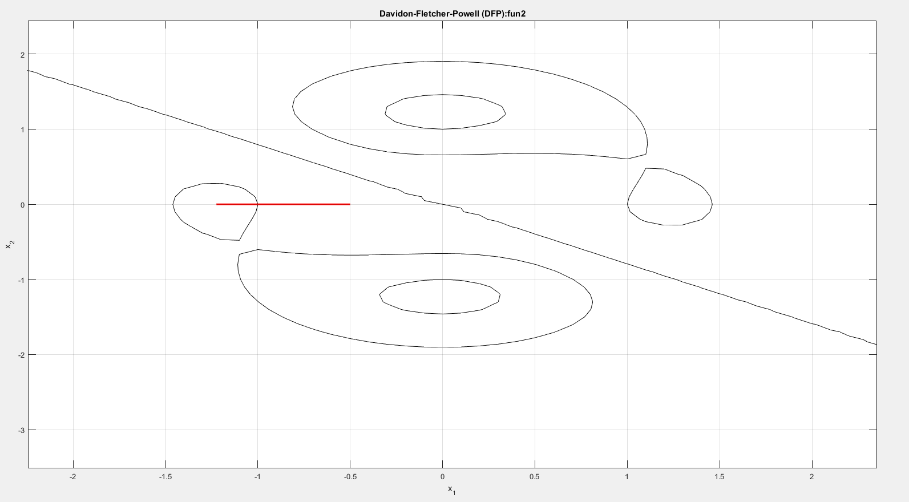

# Funkcja 3

Wzór: f(x) =

Wynik działania algorytmu:

fmin = -1.091234053580764

xmin = [-1.124009445610160, -0.000126938443592]

Ilość kroków głównej pętli algorytmu: 1

Ilość kroków złotego podziału: 21

Poszczególne kroki złotego podziału:

|  |  |  |
| --- | --- | --- |
| X0 | X1 | Y |
| -0.885665563062817 | -0.078453598205620 | -0.861869769122374 |
| -1.271322120733265 | -0.156905364499079 | -1.109503077827378 |
| -1.362362333549873 | -0.175425120891498 | -1.074257204206621 |
| -1.215053098216492 | -0.145458899720385 | -1.114058085557528 |
| -1.180278468126933 | -0.138384908371173 | -1.109815649780068 |
| -1.236546176747224 | -0.149831105871903 | -1.113958609908807 |
| -1.201771044788626 | -0.142757012430527 | -1.113084904560412 |
| -1.223263119592998 | -0.147129014400100 | -1.114263053208762 |
| -1.228336465540841 | -0.148161054288207 | -1.114239229083072 |
| -1.220126946033374 | -0.146491041700656 | -1.114220365394899 |
| -1.225200675374574 | -0.147523159580140 | -1.114267485054173 |
| -1.226398599589143 | -0.147766846012147 | -1.114261856030274 |
| -1.224460778887126 | -0.147372646940954 | -1.114267768164846 |
| -1.224003207774887 | -0.147279566034520 | -1.114266721984902 |
| -1.224743278675521 | -0.147430114153520 | -1.114267948016116 |
| -1.224918057113263 | -0.147465668267350 | -1.114267881172107 |
| -1.224635445451164 | -0.147408178296998 | -1.114267921343610 |
| -1.224810107936691 | -0.147443708823375 | -1.114267938533253 |
| -1.224702161280761 | -0.147421749892158 | -1.114267943959278 |
| -1.224768875552525 | -0.147435321170418 | -1.114267946735985 |
| -1.124009445610160 | -0.000126938443592 | -1.091234053580764 |